**User’s Manual**

**For**

**MicroBaby**

**ECE 5465 Group C**

**User Interface:**

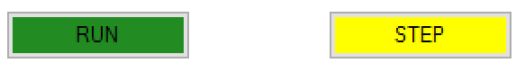

**Run**:

This button will run any preloaded code inputted into the program.

**Step**:

This button will step through – instruction by instruction – any code preloaded into and being ran, by the program.

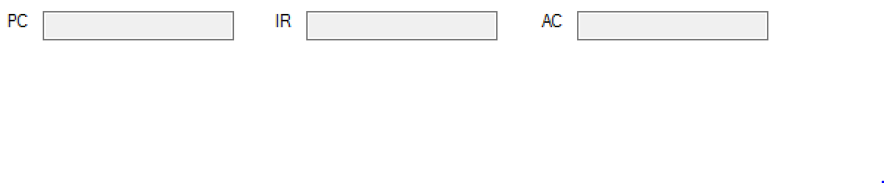**PC**:

This icon indicates the current location of the program – hence program counter.

**IR**:

This icon indicates the current value inside of the Indirect Register, inside of the MicroBaby.

**AC**:

This icon indicates the current value inside of the accumulator in the MicroBaby.

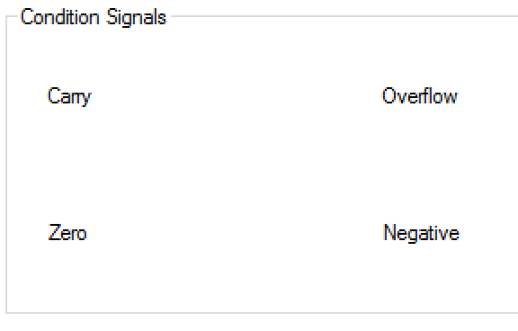

**Condition Signals:**

**Carry**:

This indicates if any carry value is currently residing inside of the carry register in the MicroBaby

**Overflow**:

This indicates if any overflow value is currently residing inside of the overflow register in the MicroBaby

**Zero**:

This indicates if any zero value is currently residing inside of the zero register in the MicroBaby

**Negative**:

This indicates if any negative value is currently residing inside of the negative register in the MicroBaby

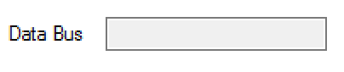

**Data Bus**:

This will display to the user the current values inside of the Data Bus of the MicroBaby

**Memory Content:**

**Simulator Display**

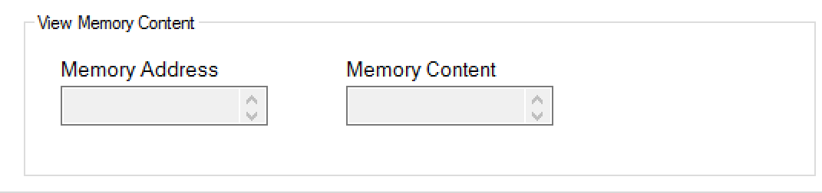

**Memory Address:**

This will allow the user to scroll through and pull up any memory address inside of the MicroBaby from the loaded code.

**Memory Content:**

This will display the content of the specific memory address that was selected in the memory address display.

**Editor Display**

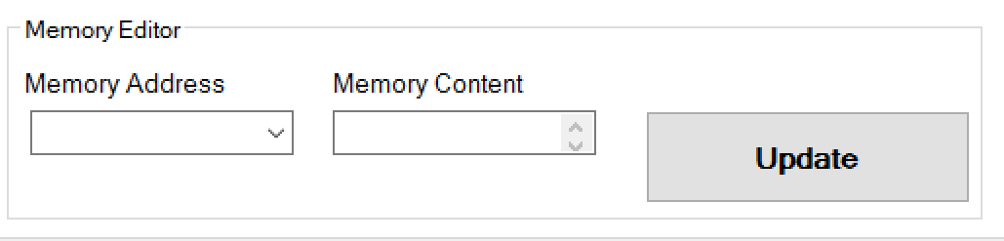

**Memory Address:**

This will allow the user to input a specific memory address into the code that will be ran through by the MicorBaby. This allows memory management before any code has been processed. Update will bring the values to the newest entered designation.

**Memory Content:**

This will allow the user to input a value into the memory addresses that were already inputted into the code in the previously mentioned memory address article. Update will bring the values to the newest entered designation.

**Code Editor:**

**Load Program:**

This will allow a user to preload a previously constructed program with data values into the MicroBaby. No code entering or data manipulation needs to be done.

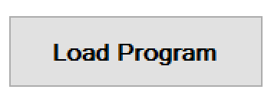

**Enter Code:**

This box provides an area for any user to implement and design code to be ran by the MicroBaby. It is a designated area for code construction.

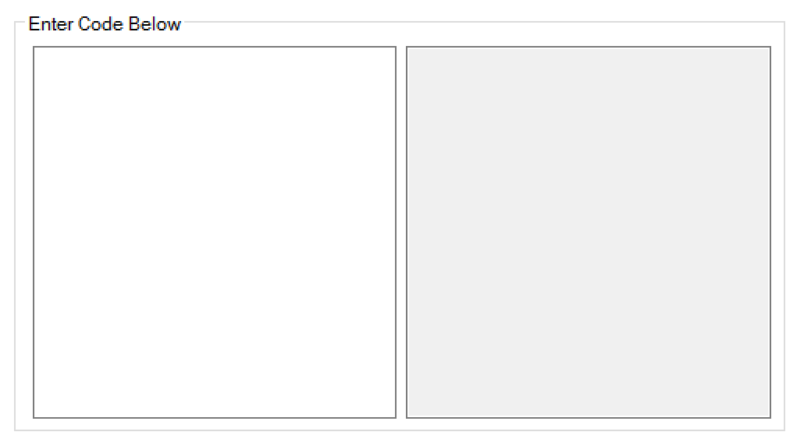

**Immediate Mode #**

**Direct Mode $**

**References:**

* For how each instruction works operates, please look at the provided MicroBaby Specifications documents.